**Explanatory note**

● Program name: Battleship

● Classical battleship game created in wpf. It includes 2 game modes such as player vs player and player vs computer.

Artificial intelligence can place ships according to the game rules and shot algorithm makes it a worthy opponent.

● Repository link: <https://github.com/Unluck/battleship>

● There are 2 members: Semyon Mitrofanov(General logic) and Yuriy Kirillov(UI, Secondary logic)

● Data and Logic:

GameSetting.cs - basic game setting (user name)

Location.cs - constructor for locations of ship

Repository.cs - class for saving all data

Ship.cs - constructor for ship initialization

ComputerLogic.cs - logic for random placement and computer shooting

Events.cs - class for receiving result of the shot

LeaderBoard.cs - logic for download and upload from file

ShipPlacement.cs - logic for manual ship placement for user

● UI:

GameResultWindow - showing result of the game

LeaderboardPage - showing information about the best games

ModeSelectionPage - selection of mode

OnePlayerPage - game mode player vs computer

ShipPlacementPage - ship placement in mode player vs computer

StartingPage - starting page of the game

TwoPlayersPage - game mode player vs player

TwoPlayersShipPlacementPage - ship placement in mode player vs player

● Program interface(next page)

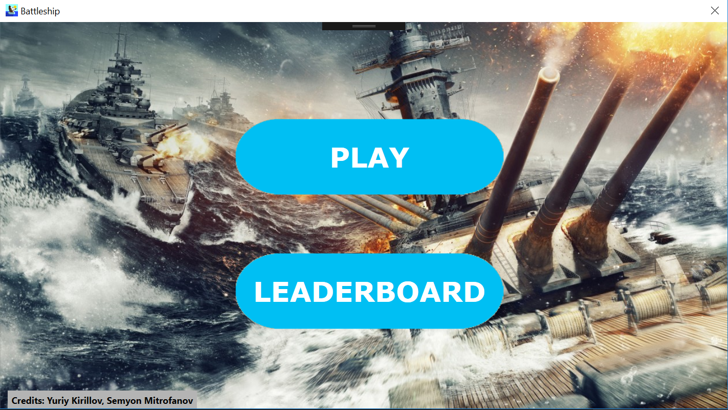

Pic 1. Starting page of the program.

This is a starting page. Here you can choose whether to start game or check leaderboard.

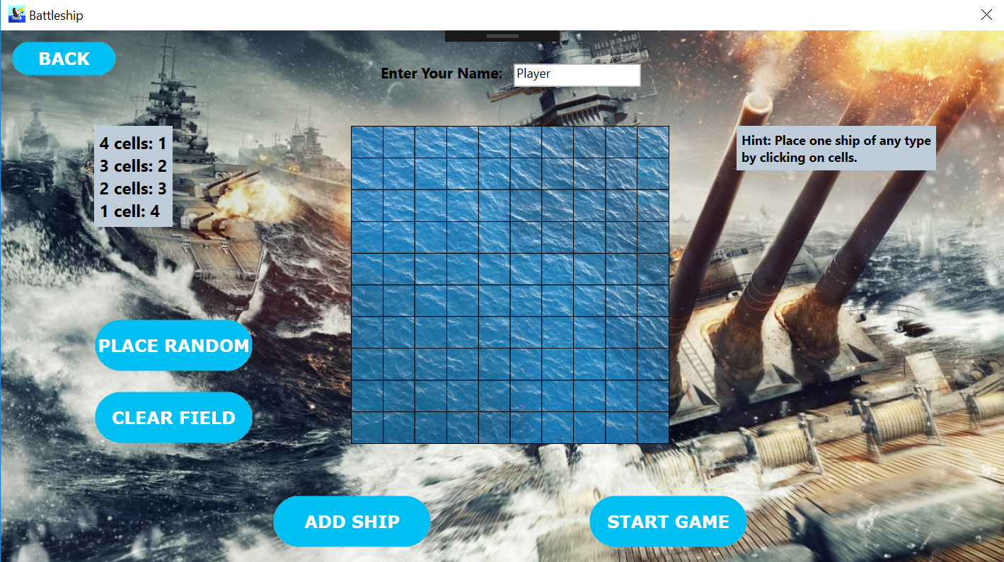

Pic 2. Ship placement in mode player vs computer.

On this picture is shown page for ship placement. You can place ships manually by clicking on cells and then using «Add ship» button, or choose random placement. Also player can change name in textbox on the top of a page.

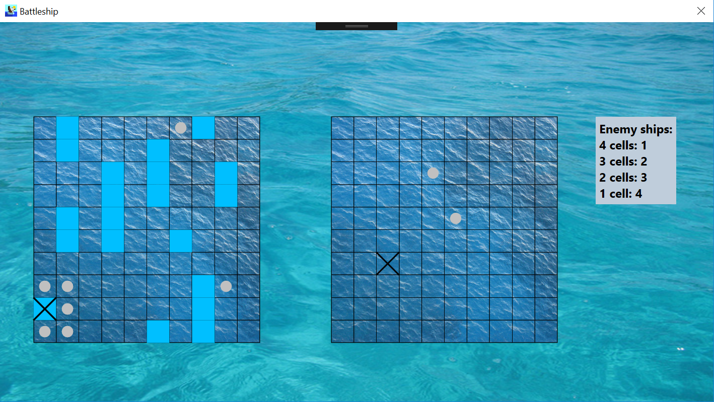

Pic 3. Player vs computer gameplay process.

Here you can see gameplay process. Misses are shown as dots on cells, hits and kills are shown as crosses. Also there is a label with remaining ships on the right.

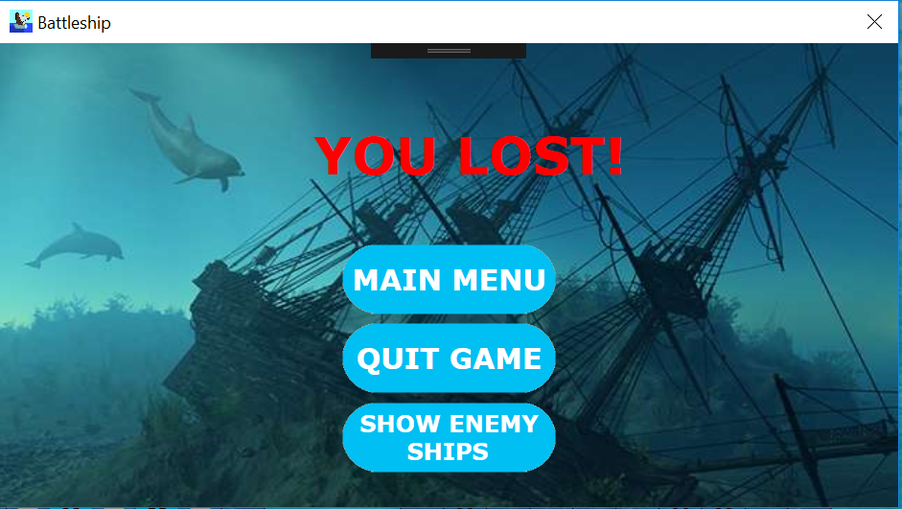

Pic 4. Game result window in case of loss.

When you lose, this window is shown. You can select 3 options that allows you to go to main menu, to leave game or to check remaining ships of your enemy.

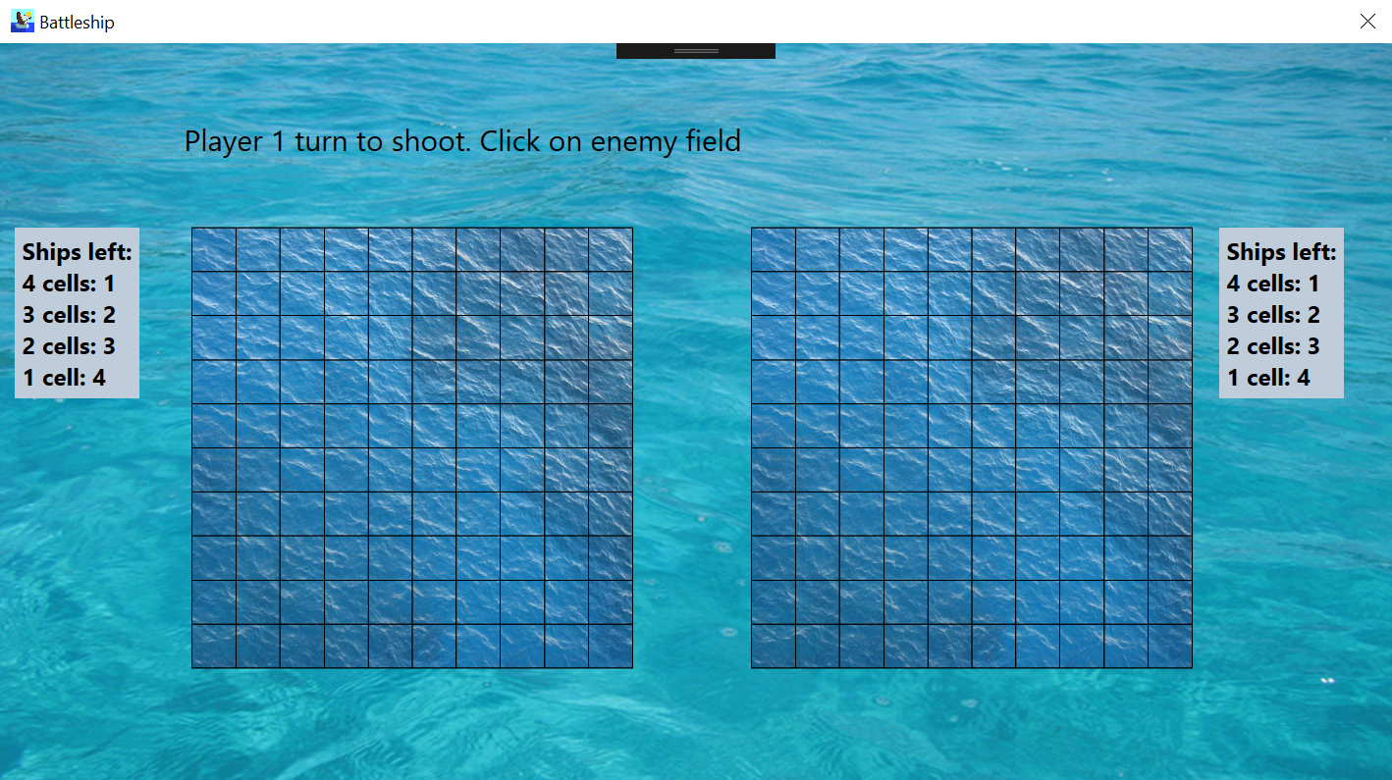

Pic 5. Player vs player gameplay process.

This screenshot shows process of player vs player game mode. All actions are marked on the label, which also displays hints for players. Also there are two tables with the remaining ships of players.

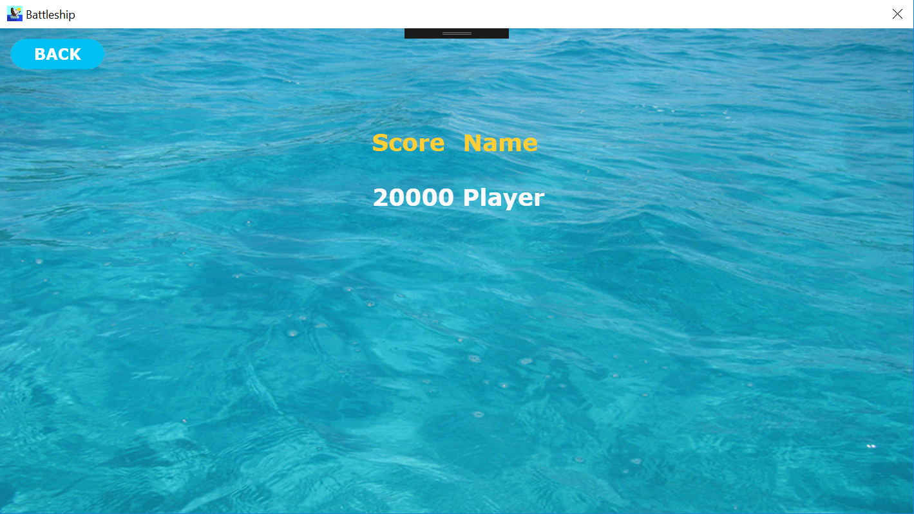

Pic 6. Leaderboard window.

Leaderboard page shows five best results in the game. It displays score and name, that player can change before starting the game.